GIS/Spatial Analysis Lab #1
Downloads Software: QGIS 3.4 (use QGIS Desktop)
Lab 1 File: newsweek_data.shp and accompanying files.

Lab 1 Info: Types of Files Used by QGIS:
- .dbf: A database file, with data in tabular form.
- .shx: A required file.
- .shp: A shapefile, which is imported into GIS software. This is the file you interact with.
- .prj: A projection file (not in this lab), which contains data on how we project data onto a plane (e.g., flattening a sphere onto a plane).

Step 1: Importing Data
- Go to Layer > Add Layer > Add Vector Layer to import your .shp file. Since there is no projection data, we’ll use the default, WGS 84
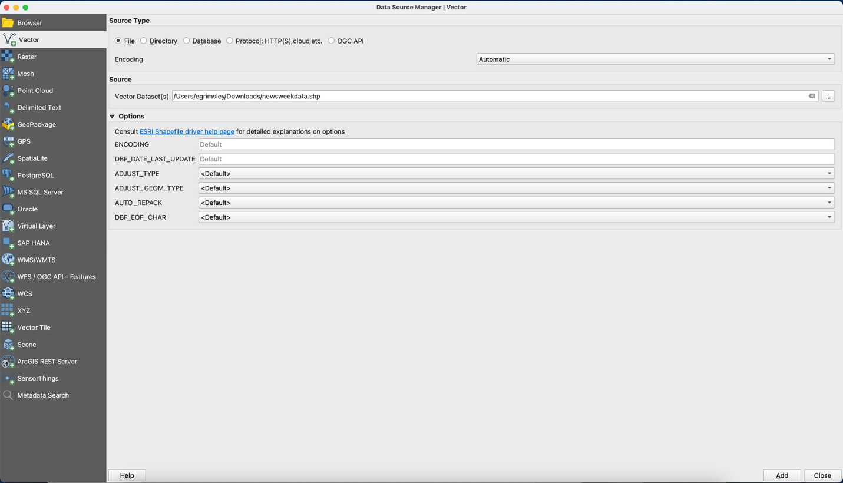

Step 2: Selecting Regions
- Draw a box using the select button to choose a region.
- Try selecting one of the continents.
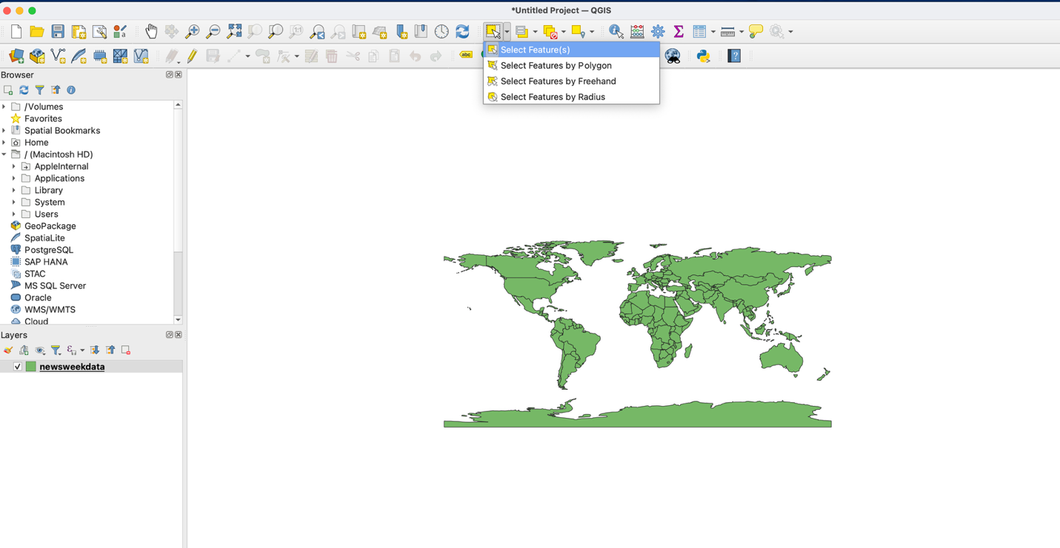

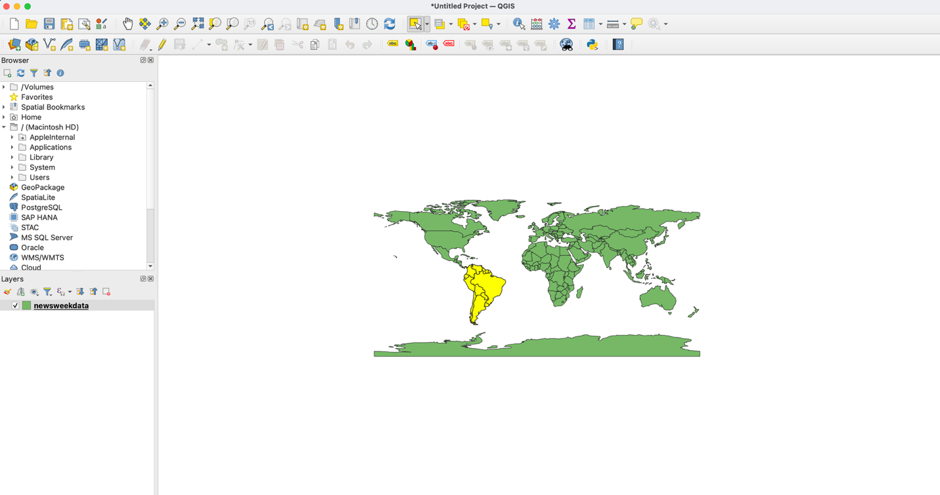

Step 3: Exporting Selected Region to New Layer
- Go to Layer > Save As.
- Check the Save only selected features box.
- Save the new layer as a .shp file.
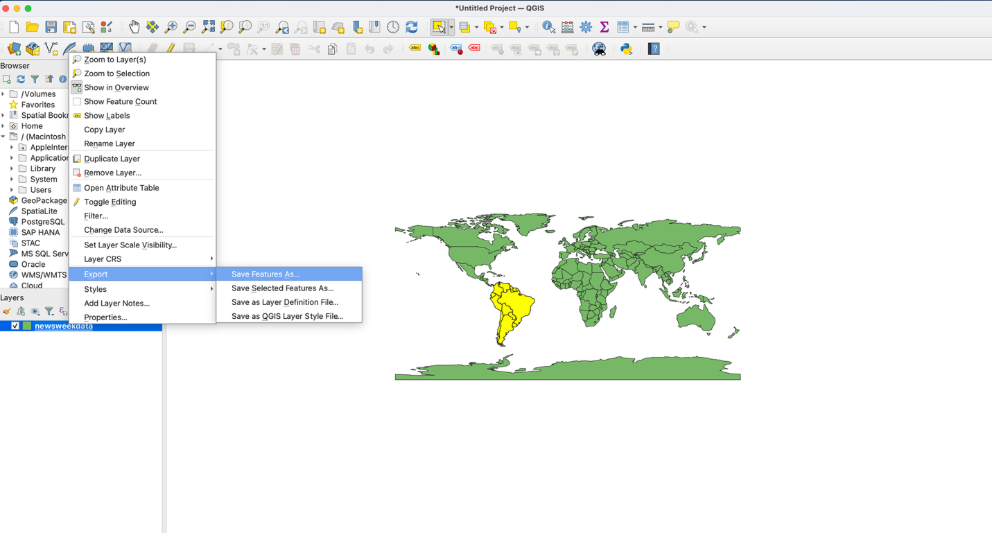

Step 4: Removing the Rest of the World
- Right-click newsweek_data on the Layers Panel and click Remove.

Step 5: Inspecting Data
- Right-click on South America in the Layers Panel.
- Click on Attribute Table to view the data.
- Use the Expression Builder to filter out specific data if needed.
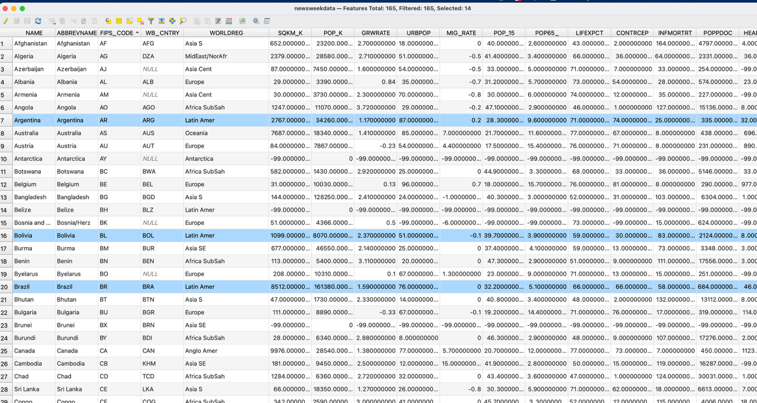

Step 6: Changing Style of Objects
- Right-click on South America again, go to Properties, and click on the Style tab.
- Change the color, fill, and outline of the region.
- Try categorizing the data by selecting Categorized or Graduated styles. For example, choose POP_K and click Classify.
- Adjust the classification mode (e.g., Quantile for population).
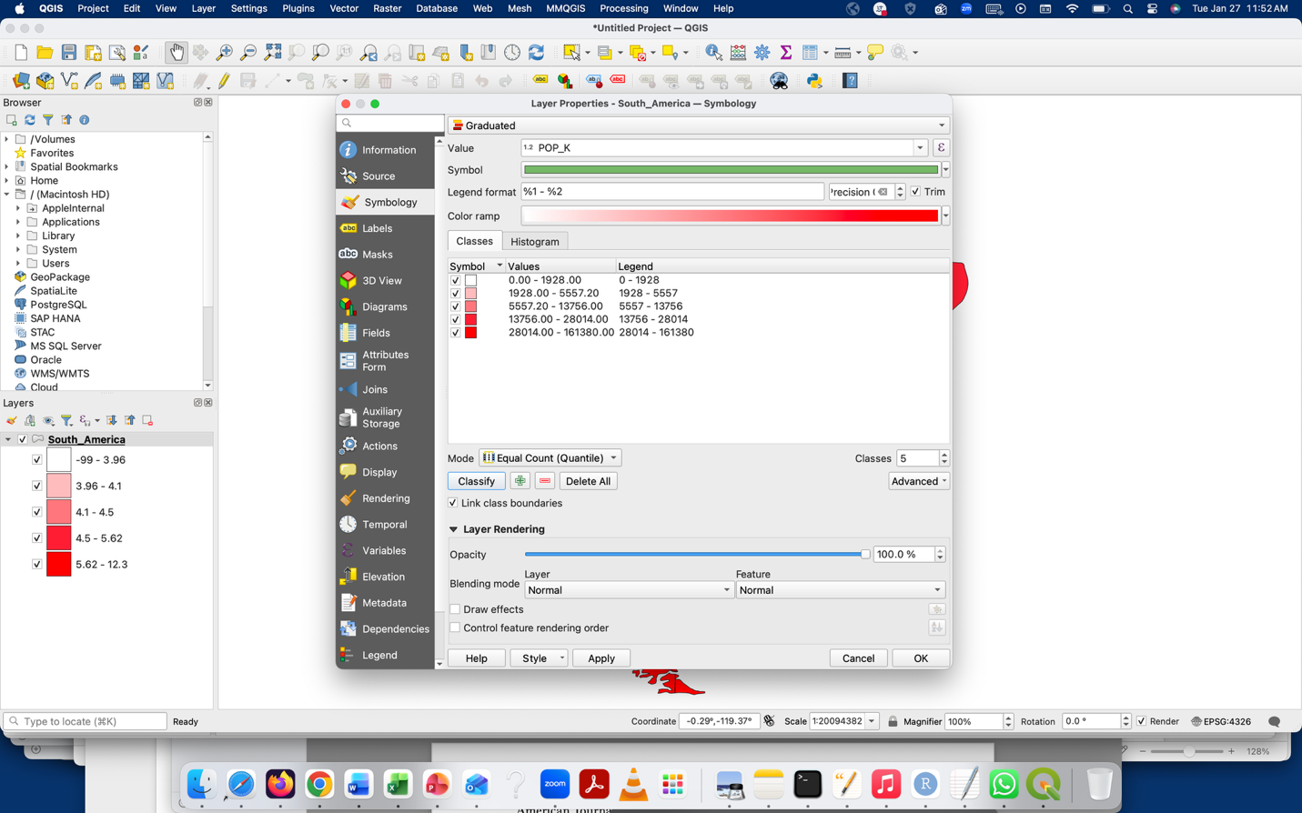
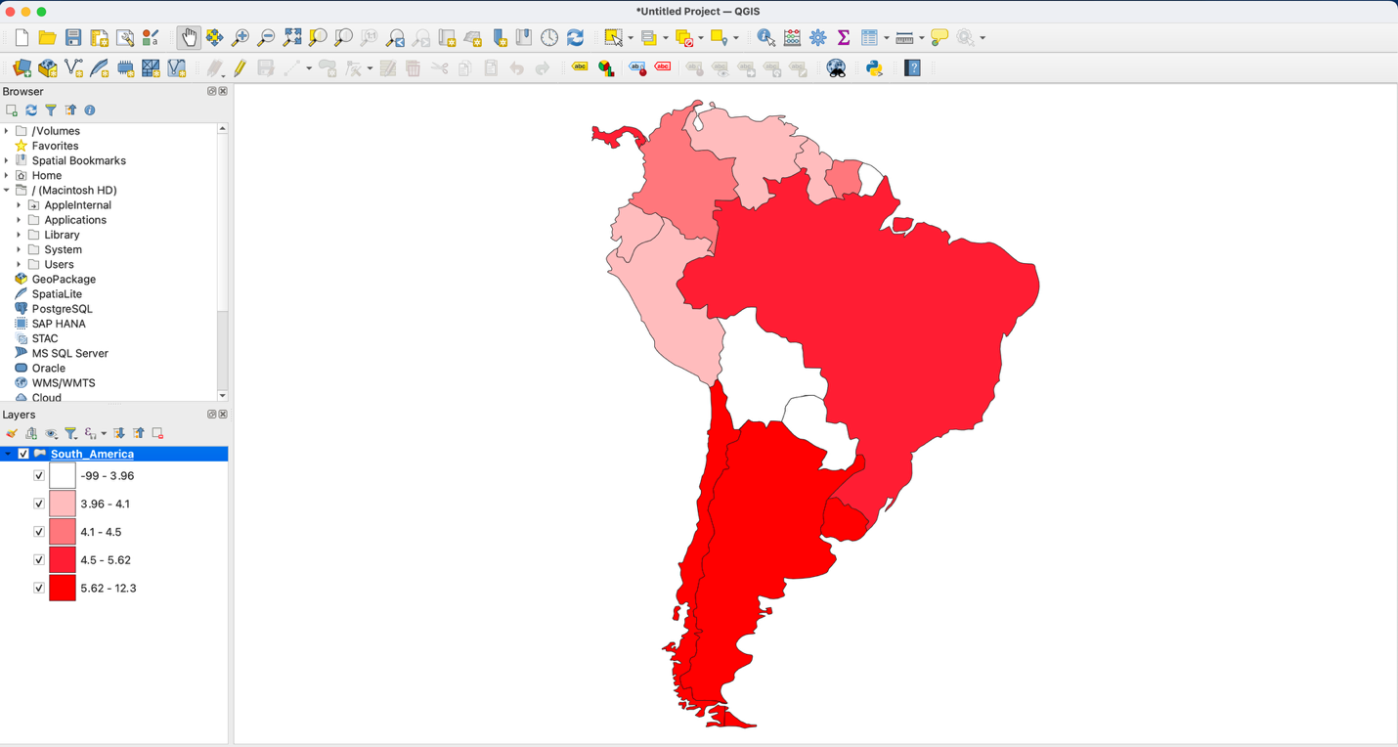

Step 7: Select the Continent Layer (Optional)
- Duplicate the layer and ensure both layers are selected.
- Right-click on your country layer and go to Properties.
- Adjust the Line (Boundary) Style in the Symbology tab.
  - Change the boundary to Simple Fill.
  - Set the fill to "No brush" or another color.
  - Change the boundary line color to black or dark gray, and adjust the line thickness.

Step 8: Select the Continent Layer Using an Expression (Another Way - Optional)
- Open the Attribute Table for the Continent layer.
- Click Select Features Using an Expression (ε icon).
- In the expression window:
  - Expand Fields and Values.
  - Note that WORLDREG is a text field.
- Enter the following expression:
"WORLDREG" = 'Africa SubSah' or "WORLDREG" IN ('Africa SubSah')
If you want to add the Middle East or another region:
"WORLDREG" IN ('Africa SubSah', 'MidEast/NorAfr') or use this: "WORLDREG" = 'Africa SubSah' OR "WORLDREG" = 'MidEast/NorAfr'
- Click Select Features.
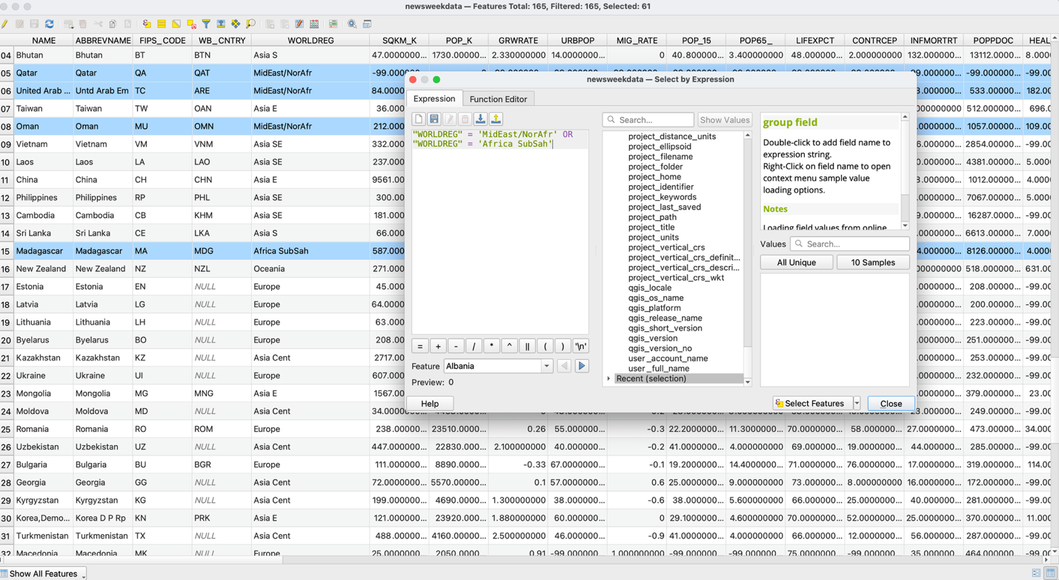

Step 9: Saving
- Go to Project > New Print Layout.
- Under the Add Items dropdown, click Add Map.
- Draw a rectangle to create your map on the canvas.
- Add titles, legends, and a scale bar using Add Item.
- Export your layout as a PDF by going to Layout > Export as PDF.

Lab Assignment Upload
Upload a Map of a Continent of Your Choice:
- Choose a continent to map (South America is fine from this lab or another one) and use one variable from the dataset to create a choropleth map.
- Follow the same style instructions to visualize the data based on the chosen variable.
- Check the sample map on Canvas for guidance on how it should look.
- Save the map as a .pdf and upload it.

